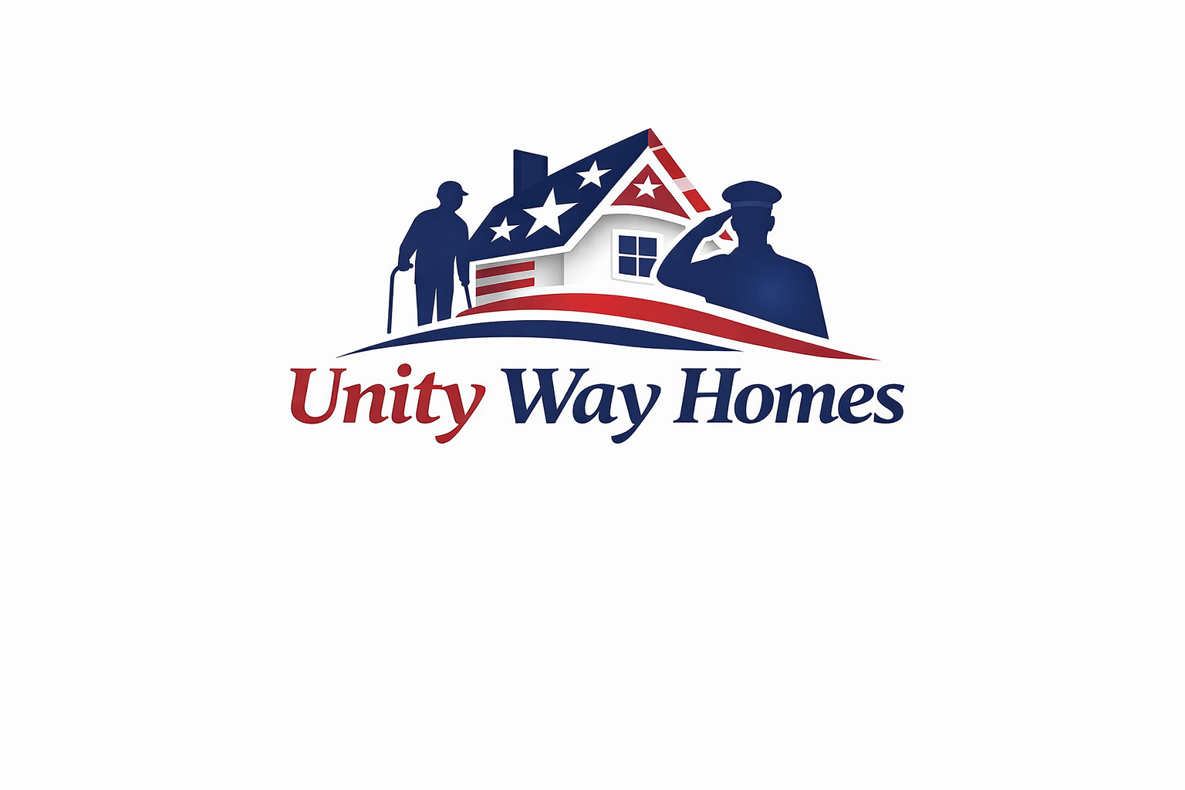
Unity Way Homes
Homeowner Partnership Agreement
Phone/Text: 901-498-4156 | Email: info@packitexpress.com | Memphis, TN & Surrounding Areas

PROGRAM OVERVIEW
Unity Way Homes partners with property owners to provide safe, stable, independent shared housing for Veterans, Seniors, and Returning Citizens. This partnership is for residential housing purposes only.
PROPERTY INFORMATION
Property Address: _______________________________________________
City / State / Zip: _____________________________________________
USE OF PROPERTY
The property will be used strictly for independent residential housing. No medical care, assisted living, supervision, or treatment services will be provided.
RENT & PAYMENT TERMS
Monthly Rent Amount: $____________________
Rent Due Date: ____________________________
Payment Method: ___________________________
MAINTENANCE & CARE
Unity Way Homes agrees to maintain general cleanliness, enforce house rules, and promptly report maintenance issues. Property owner remains responsible for major repairs.
LIABILITY
Unity Way Homes does not provide medical care or supervision. Property owner is responsible for maintaining appropriate insurance.
TERMINATION
This agreement may be terminated by either party in accordance with lease terms and applicable law.
Property Owner Name: ______________________________
Property Owner Signature: _________________________ Date: __________
Unity Way Homes Representative: ____________________ Date: __________

